ESP32 LORA
- Wemos® SX1278 LoRa ESP32 Bluetooth WIFI 433MHZ amazon
- example 1 interesting
- example 2
- ESP32 development boards
- LoRa library
- coil antenna
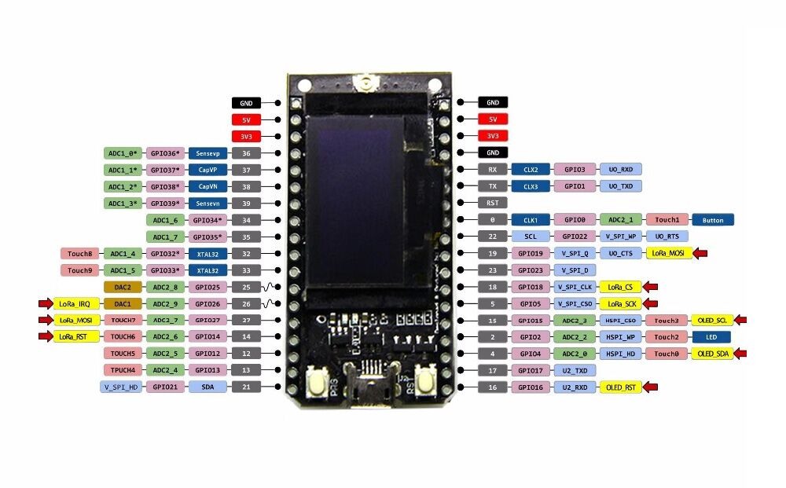
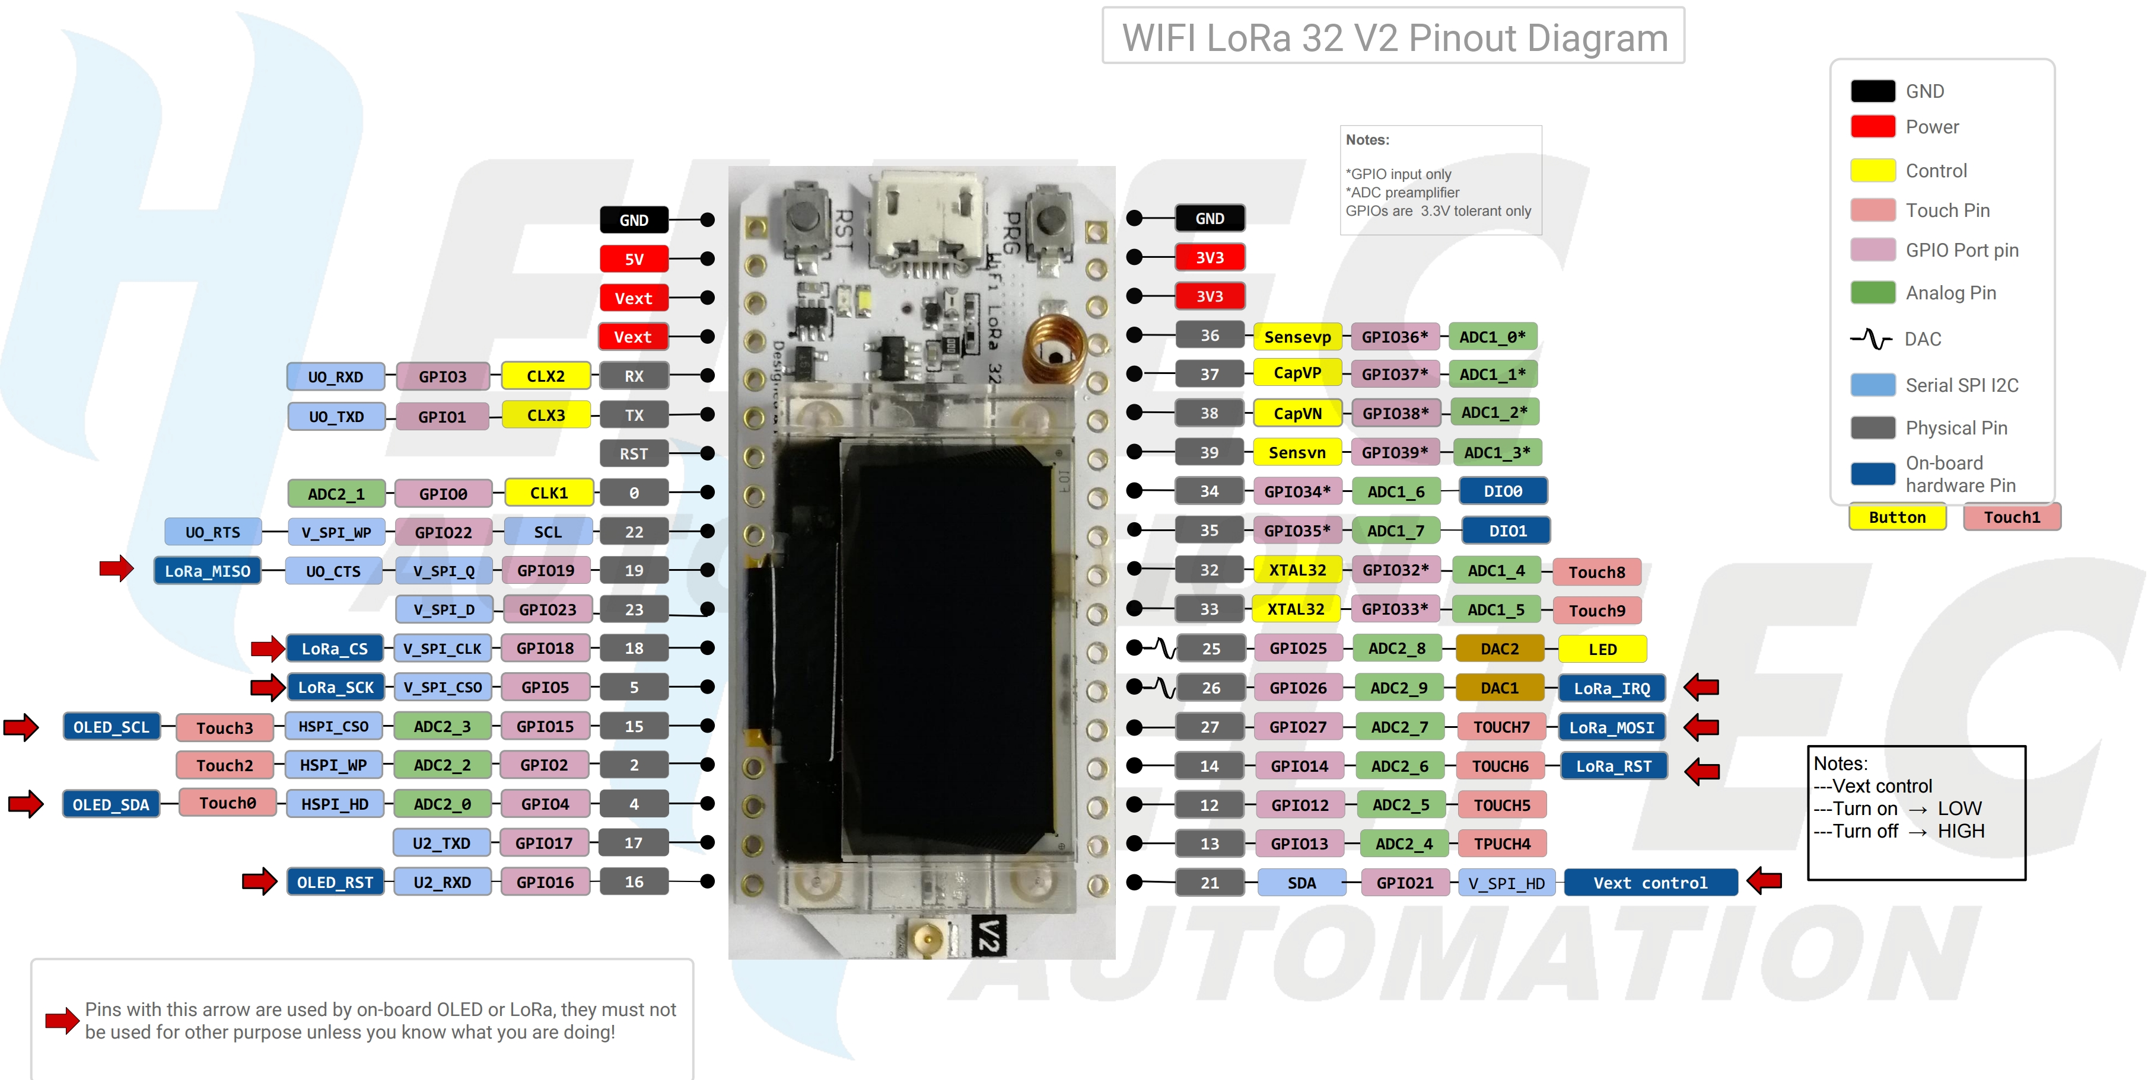
heltec esp32 lora https://escapequotes.net/esp32-lora-send-receive-packet-test/

Lora basic sender and receiver
- https://www.alictronix.com/archives/860
SX1278 433MHz
// re-define pin definitions of pins_arduino.h
#define PIN_SPI_SS 18 // ESP32 GPIO18 (Pin18) -- SX1276 NSS (Pin19) SPI Chip Select Input
#define PIN_SPI_MOSI 27 // ESP32 GPIO27 (Pin27) -- SX1276 MOSI (Pin18) SPI Data Input
#define PIN_SPI_MISO 19 // ESP32 GPIO19 (Pin19) -- SX1276 MISO (Pin17) SPI Data Output
#define PIN_SPI_SCK 5 // ESP32 GPIO5 (Pin5) -- SX1276 SCK (Pin16) SPI Clock Input
// non arduino pin definitions
#define RST 14 // ESP32 GPIO14 (Pin14) -- SX1276 NRESET (Pin7) Reset Trigger Input
#define DIO0 26 // ESP32 GPIO26 (Pin15) -- SX1276 DIO0 (Pin8) used by LMIC for detecting LoRa RX_Done & TX_Done
#define DIO1 33 // ESP32 GPIO33 (Pin13) -- SX1276 DIO1 (Pin9) used by LMIC for detecting LoRa RX_Timeout
#define DIO2 LMIC_UNUSED_PIN // 32 ESP32 GPIO32 (Pin12) -- SX1276 DIO2 (Pin10) not used by LMIC for LoRa (Timeout for FSK only)
TO BUY:
- https://www.cnx-software.com/2017/10/13/this-ttgo-board-combines-esp32-lora-radio-and-oled-display-for-just-10/ pinout

