GOOGLE HOME
- Create a new project in the https://console.cloud.google.com/home/dashboard console
  - Specify project name and country
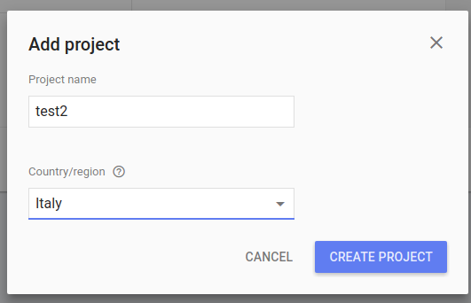
- Now you get a new project to the cloud console. Here you get a new project_id.
- Enable Homegraph API to the new project.
- Generate a new API key (the same Api key of apikey: in googleassistant.yaml)
- IAM E amministrazione/impostazioni/ESEGUI LA MIGRAZIONE (By this, they share the same projectid request in googleassistant.yaml)
- Unordered List ItemCreate a new project in the developer console.https://console.actions.google.com
- Ordered List Itema. Add/Import project, give it a name (The same project created by the Google Cloud platform above)
- Ordered List Itemb. Click on Home Control card, select the Smart home recommendation
- Ordered List Itemc. Create an Action, under the build section. Add in your home assistant url: https://[YOUR HOME ASSISTANT URL:PORT]/api/googleassistant, replace the [YOUR HOME ASSISTANT URL:PORT] with the domain / ip address and the port under which your Home Assistant is reachable. If you have set apipassword: add this password to the URL - eg https://[YOUR HOME ASSISTANT URL:PORT]/api/googleassistant?apipassword=[YOUR API PASSWORD])
- Unordered List Item - Ordered List Itemd. Click Done. Then click on Overview, which will lead you back to the app details screen.
- Unordered List ItemAccount linking is required for your app to interact with Home Assistant. Set this up under the Quick Setup section
  - Ordered List Itema. Leave it at the default No, I only want to allow account creation on my website and select Next
  - Ordered List Itemb. For the Linking type select OAuth and Implicit
  - Ordered List Itemc. Client ID: The clientid from your Home Assistant configuration above - Ordered List Itemd. Authorization URL (replace with your actual URL): https://[YOUR HOME ASSISTANT URL:PORT]/api/googleassistant/auth. If you have set apipassword: add this password to the URL https://[YOUR HOME ASSISTANT URL:PORT]/api/googleassistant/auth?apipassword=[YOUR API PASSWORD]) - Ordered List Iteme. Configure your client. Add scopes for email and name. - Ordered List Itemf. Testing instructions: Enter anything. It doesn’t matter since you won’t submit this app. * Unordered List ItemBack on the overview page. Click Simulator under TEST - you don’t have to actually test . If you haven’t already added the component configuration to configuration.yaml and restarted Home Assistant, you’ll be unable to continue until you have. Open the Google Assistant app and go into Settings > Home Control Click the + sign, and near the bottom, you should have [test] your app name. Selecting that should lead you the screen where you can set rooms for your devices or nicknames for your devices. If you want to allow other household users to control the devices: a. Go to the settings for the project you created in point 1 in the developer console. b. Under the gear icon, click Permissions c. Click Add, type the new user’s e-mail address and choose Project → Editor role d. Have the new user go to developer console and repeat steps starting from point 4 ===== googleassistant.yaml =====
<code> googleassistant: projectid: someproject-2d0b8 clientid: [long URL safe random string] accesstoken: [a different long URL safe random string] agentuserid: [a string to identify user] apikey: [a Homegraph API Key generated for the Google Actions project] exposeddomains:
  - switch
  - light
  - group entityconfig: switch.kitchen: name: Custom Name for Google Assistant aliases: - bright lights - entry lights light.livingroom: expose: false room: living room </code>
  - Reset Home Assistant and TEST Action
  - Open the Google Assistant app and go into Settings > Home Control
  - Click the + sign, and near the bottom, you should have [test] your app name. Selecting that should lead you the screen where you can set rooms for your devices or nicknames for your devices.

