Blender 2.9

shortcuts
- SHIFT z: switch wireframe and object mode
- f: fill faces or edges between edges or vertex
- a: select all
- ALT+a: select nothing
- c: circle select
- b: box select
- SHIFT+b: zoom to box
- SHIFT+s: cursor move or selection move
- w: cycle between selecion modes

numpad emulation
- edit → preferences → input → emulate numpa
- enable 1,2,3 switch faces,edges,vertex: edit → preferences → keymap → search mode
  - select mode toggle: ALT+1
  - select mode toggle: ALT+2
  - select mode toggle: ALT+3

fix boolean operations
Sometimes boolean difference fails. Before try on each object:
- edit mode
- select all vertices A
- vertex (top menu) → Merge Vertices → by distance (this operation remove duplicate vertices)

hide / show
- select (multiple) object and SHIFT+H to hide others
- recall others with ALT+H

edit mode
TAB key
- activate Vertex select with 1, Edge select with 2 and Face select with 3
Create new object from selected vertex:
- duplicate with SHIFT+d
- ESC to exit from grab mode
- parent selected with “p”
- exit from edit mode with TAB and you will have two objects
CTRL+l: select touching vertex, edges, faces
Recalculate normals (to solve bevel problems): select all with “a” and hit “shift+n”
knife mode K:
- c for angle constrain
- z for cut all deeper edges
put vertex same X, Y or Z:
- position the 3d cursor at the Y location
- set the pivot point to the 3d cursor (. period key)
- then scale by zero on the Y axis (S Y 0)

blendercam
Vevor 3018pro amazon
cd /lab/blender
git clone https://github.com/vilemnovak/blendercam.git
edit blender_manifest.toml commenting shapely wheels
install system packages
yay -S opencamlib python-numba python-shapely
setup blender scripts alternate file path
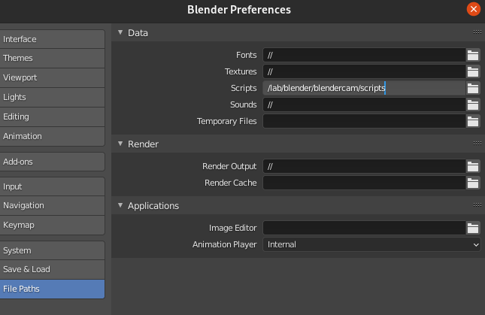
save preferences restart blender and enable blendercam add-on
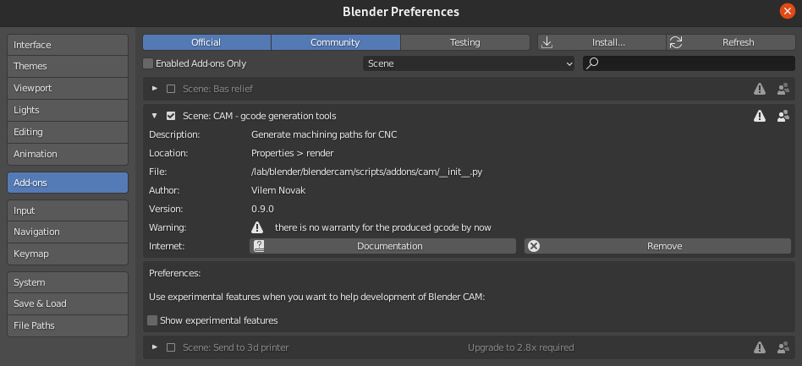
select CAM render engine in scene tab
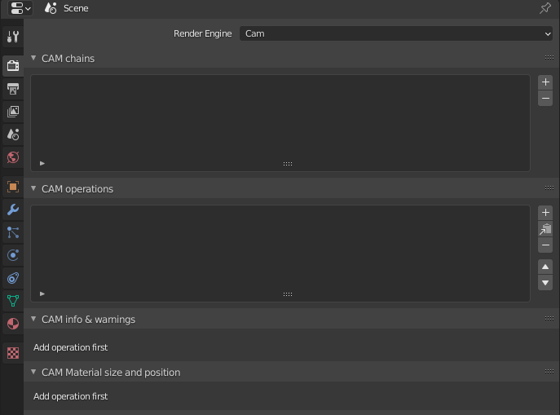
CAM machine → add preset '3018pro' with 'iso' post processing
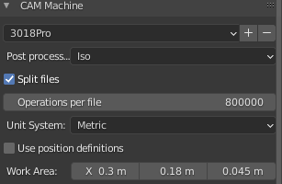
CAM operations → add one operation and select target object
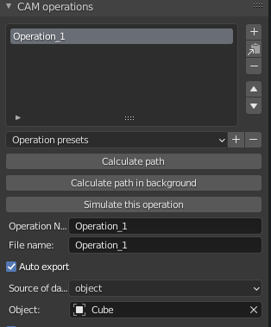
CAM material size and position → put object into job area with position button
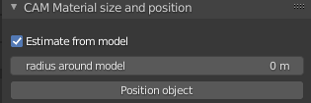
CAM cutter
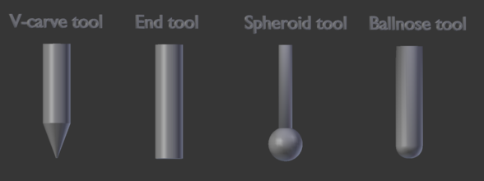
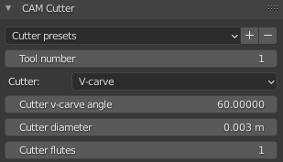
CAM operation setup → strategy parallel and skin
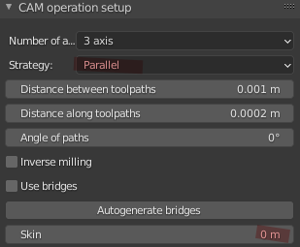
header gcode to increase velocity spindle motor Genmitsu GS-775M 775 to 7000 (it double velocity x2)
M03 S1000
G4 P0.5
M03 S2000
G4 P0.5
M03 S3500
M03 S1000;G4 P0.5;M03 S2000;G4 P0.5;M03 S3500

