GPIO
- interface circuits
GPIO numbers (BCM mode)
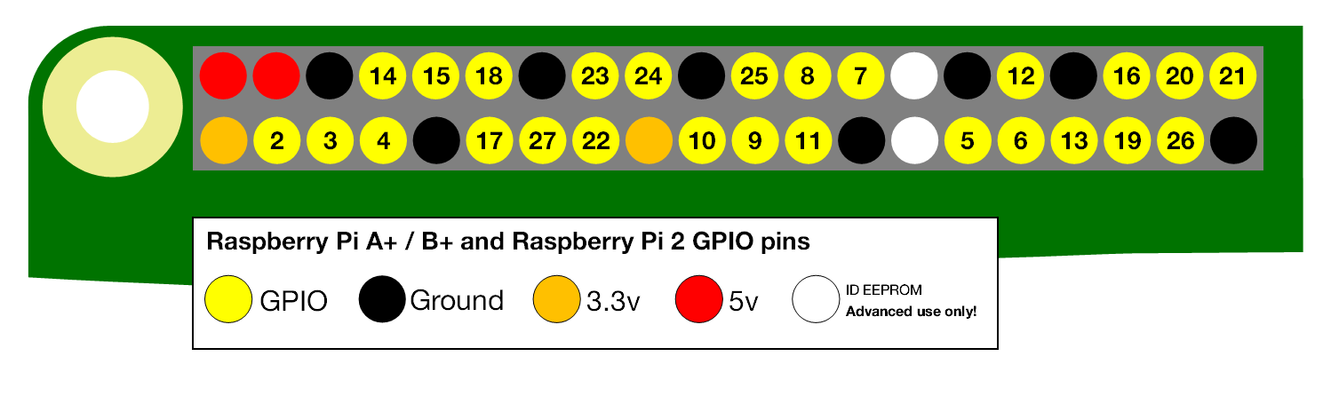
physical number (BOARD mode)
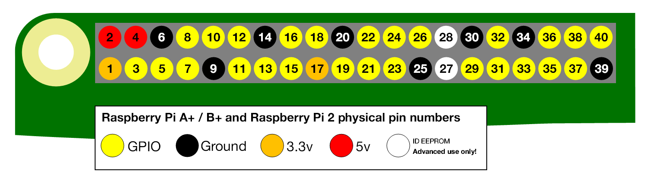
test pin 17
gpio -g mode 17 out
gpio -g write 17 1
sleep 2
gpio -g write 17 0
python
import RPi.GPIO as GPIO
import time
GPIO.cleanup()
GPIO.setmode(GPIO.BOARD)
channel=11
GPIO.setup(channel, GPIO.OUT)
while True:
GPIO.output(channel, GPIO.HIGH)
time.sleep(1)
GPIO.output(channel, GPIO.LOW)
time.sleep(1)

